Intro Germany

We as a team think that it is very important to understand the connection between all the countries of the world. We also believe, It is true the most effective way to experience this connection is to visit the country but also to be accepted into its society. Not just going there and saying that you know what it is to be German. For example I am sure we are all proud to be Irish, but yet none of us really have any explanation of what it means other than drinking and most people would say the same about Germany. But, all countries have different beliefs, cultures, customs, languages and more! And before we go to work, live or just even visit these countries, we have to understand the different ways of living. For example, our class is studying German and some of us will be going to Germany to either study or work. And they will need to identify how to fit in with the community and understand their way of life. On a whole this is what we think Global Citizenship is about not just visiting countries and seeing these beliefs and cultures but actually understanding them and being accepted into the society as if they were a citizen there from the beginning.

Religion in Germany

* Christianity largest religion: 63% of total population 34% Atheist
* 32% Protestant 31% Catholics
* Second Biggest: Islam 5% followed by Buddhism .25% and Judaism .25%
* Hamburg non-religious state (due to losses of both Protestant and Catholic Churches)
* Constitution you are a citizen or you are not, "No one may be discriminated against because of his sex, his heritage, his race, his language, his birth-place, his beliefs, his religious or political ideologies."- German Constitution.
* After criticizing the letters and the audacity of the racists, Bekir Yılmaz, president of the Berlin Turkish Society, said his group opened a forum on its website to receive complaints about discrimination. After a week, he said, it had received around 1,800 complaints. According to Yılmaz, foreigners face discrimination in applying for government jobs and in finding housing.
* During the German Election campaigns, the Ultranationalist National Democratic Party (NPD) mailed letters to candidates of foreign descent explaining why they should leave Germany. One of these openly racist letters said German citizens of foreign descent should be “forbidden to manipulate the physical and psychological state of a group.” “One-way tickets” for immigrant candidates were attached to the letters.
* In the course of the Protestant Reformation and the ensuing Thirty Years’ War in the 15th and 16th centuries, religion in Germany ended up being distributed according to the preferences of local rulers: Therefore, most areas in the South or West (especially Bavaria and Northrhine-Westphalia) are Catholic while the North and East are mainly Protestant. However, the Communist regime of the former GDR (German Democratic Republic) frowned upon religion in Germany’s eastern parts until the reunification in 1990. This explains why the percentage of self-confessed atheists is particularly high in these federal states. Other strands of Christian religion in Germany are the so-called Free Evangelical Churches, a loose union of congregations adhering to Baptism, Methodism and related faiths such as the Mennonites.
* Don’t celebrate religious days seen as commercial days off or days off work an early age brought up to make their own decisions and not really follow any religious belief.

Sport in Germany

* Top 3 sports: Football, Basketball, Ice Hockey
* An exhibit of historical soccer jerseys in Salvador, Brazil has flared into controversy because of its inclusion of a 1934 German replica uniform. The white garment with a reichsadler, or imperial eagle, perched on a swastika has many wondering who could have made such an insensitive oversight. While looking at the 1934 regalia, Rolf Zettel of Fribourg, Switzerland told the Associated Press: “Is this a joke or what? Germany 1934 [was] a despicable time. Is this OK? No it’s not OK.”
* 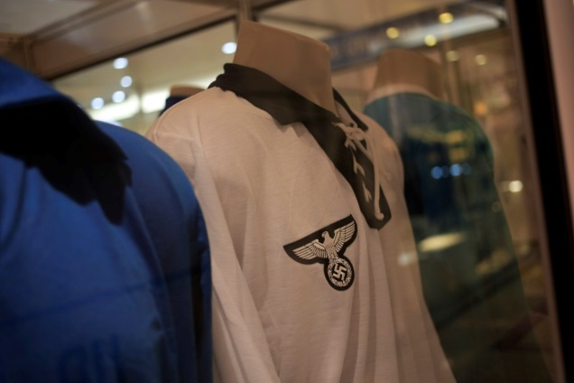
* Prior to the debut of this year’s World Cup, Germany was not only a favorite to win the tournament, but was voted the most popular country in the world. But while Deutschland still has a loose cup chance, its popularity may be waning after a few controversies that have seen the country’s Nazi past re-emerge and which throw an unwelcome spotlight on the country’s present, albeit isolated, neo-Nazism.
* 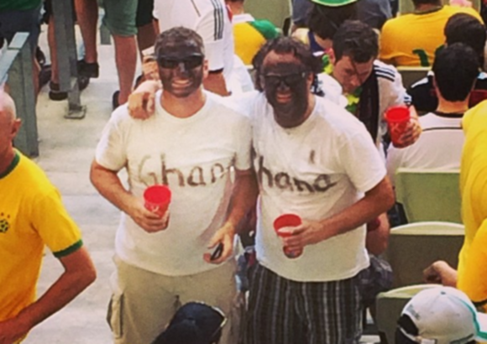
* A photograph of two German fans in black face at the Germany vs Ghana match sparked an online storm, with FIFA promising to investigate. Reports say that several German fans came to the match on June 21 in blackface.